Ch9 - Packet Tracer Skills Integration Challenge

Topology Diagram
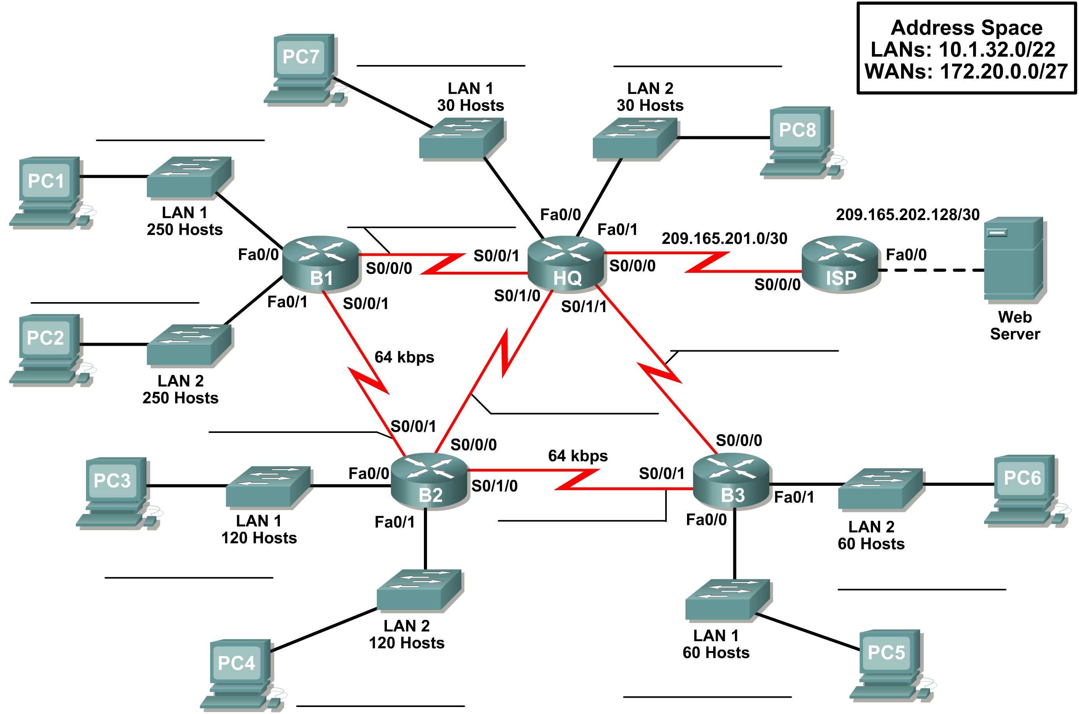

Introduction:

This Packet Tracer Skills Integration Challenge Activity is similar to the activities you created for Chapter 7, "RIPv2". The scenario is slightly different, to allow you to better practice your skills. In this activity, you build a network from the ground up. Starting with a given address space and network requirements, you must implement a network design that satisfies the specifications. Then implement an effective EIGRP routing configuration, manually summarize routes, fine-tune EIGRP metrics and timers, and configure static and default routing for Internet access.

Objectives:
- Design and document an addressing scheme based on requirements.
- Apply a basic configuration to the devices.
- Test connectivity between directly connected devices.
- Configure and verify EIGRP routing.
- Configure EIGRP summary routes.
- Fine-tune EIGRP.
- Configure static and default routing for Internet access.
- Verify full connectivity between all devices in the topology.

B1 | Network | First | Last | Broadcast | Mask
Fa0/0 | 10.1.32.0 /24 | 10.1.32.1 /24 | 10.1.32.254 /24 | 10.1.32.255 /24 | 255.255.255.0
Fa0/1 | 10.1.33.0 /24 | 10.1.33.1 /24 | 10.1.33.254 /24 | 10.1.33.255 /24 | 255.255.255.0
B2 | Network | First | Last | Broadcast | Mask
Fa0/0 | 10.1.34.0 /25 | 10.1.34.1 /25 | 10.1.34.126 /25 | 10.1.34.127/25 | 255.255.255.128
Fa0/1 | 10.1.34.128 /25 | 10.1.34.129 /25 | 10.1.34.254 | 10.1.34.255 /25 | 255.255.255.128
B3 | Network | First | Last | Broadcast | Mask
Fa0/0 | 10.1.35.0 /26 | 10.1.35.1 /26 | 10.1.35.62 /26 | 10.1.35.63 /26 | 255.255.255.192
Fa0/1 | 10.1.35.64 /26 | 10.1.35.65 /26 | 10.1.35.126 /26 | 10.1.35.127 /26 | 255.255.255.192
HQ | Network | First | Last | Broadcast | Mask
Fa0/0 | 10.1.35.128 /27 | 10.1.35.129 /27 | 10.1.35.158 /27 | 10.1.35.159 /27 | 255.255.255.224
Fa0/1 | 10.1.35.160 /27 | 10.1.35.161 /27 | 10.1.35.190 /27 | 10.1.35.191 /27 | 255.255.255.224

WAN | Network | First | Last | Broadcast | Mask
Subnet0 | 172.20.0.0 /30 | 172.20.0.1 /30 | 172.20.0.2 /30 | 172.20.0.3 /30 | 255.255.255.252
Subnet1 | 172.20.0.4 /30 | 172.20.0.5 /30 | 172.20.0.6 /30 | 172.20.0.7 /30 | 255.255.255.252
Subnet2 | 172.20.0.8 /30 | 172.20.0.9 /30 | 172.20.0.10 /30 | 172.20.0.11 /30 | 255.255.255.252
Subnet3 | 172.20.0.12 /30 | 172.20.0.13 /30 | 172.20.0.14 /30 | 172.20.0.15 /30 | 255.255.255.252
Subnet4 | 172.20.0.16 /30 | 172.20.0.17 /30 | 172.20.0.18 /30 | 172.20.0.19 /30 | 255.255.255.252

Addressing Table
Device | Interface | IP Address | Subnet Mask |  | Default Gateway
HQ | Fa0/0 | 10.1.35.129 |  | 255.255.255.224 | N/A
HQ | Fa0/1 | 10.1.35.161 |  | 255.255.255.224 | N/A
HQ | S0/0/0 | 209.165.201.2 |  | 255.255.255.252 | N/A
HQ | S0/0/1 | 172.20.0.1 |  | 255.255.255.252 | N/A
HQ | S0/1/0 | 172.20.0.5 |  | 255.255.255.252 | N/A
HQ | S0/1/1 | 172.20.0.9 |  | 255.255.255.252 | N/A
B1 | Fa0/0 | 10.1.32.1 |  | 255.255.255.0 | N/A
B1 | Fa0/1 | 10.1.33.1 |  | 255.255.255.0 | N/A
B1 | S0/0/0 | 172.20.0.2 |  | 255.255.255.252 | N/A
B1 | S0/0/1 | 172.20.0.13 |  | 255.255.255.252 | N/A
B2 | Fa0/0 | 10.1.34.1 |  | 255.255.255.128 | N/A
B2 | Fa0/1 | 10.1.34.129 |  | 255.255.255.128 | N/A
B2 | S0/0/0 | 172.20.0.6 |  | 255.255.255.252 | N/A
B2 | S0/0/1 | 172.20.0.14 |  | 255.255.255.252 | N/A
B2 | S0/1/0 | 172.20.0.17 |  | 255.255.255.252 | N/A
B3 | Fa0/0 | 10.1.35.1 |  | 255.255.255.192 | N/A
B3 | Fa0/1 | 10.1.35.65 | 255.255.255.192 |  | N/A
B3 | S0/0/0 | 172.20.0.10 | 255.255.255.252 |  | N/A
B3 | S0/0/1 | 172.20.0.18 | 255.255.255.252 |  | N/A
ISP | Fa0/0 | 209.165.202.129 | 255.255.255.252 |  | N/A
ISP | S0/0/0 | 209.165.201.1 | 255.255.255.252 |  | N/A
Web Server | NIC | 209.165.202.130 | 255.255.255.252 |  | 209.165.202.129
PC1 | NIC | 10.1.32.254 | 255.255.255.0 |  | 10.1.32.1
PC2 | NIC | 10.1.33.254 | 255.255.255.0 |  | 10.1.33.1
PC3 | NIC | 10.1.34.126 | 255.255.255.128 |  | 10.1.34.1
PC4 | NIC | 10.1.34.254 | 255.255.255.128 |  | 10.1.34.129
PC5 | NIC | 10.1.35.62 | 255.255.255.192 |  | 10.1.35.1
PC6 | NIC | 10.1.35.126 | 255.255.255.192 |  | 10.1.35.65
PC7 | NIC | 10.1.35.158 | 255.255.255.224 |  | 10.1.35.129
PC8 | NIC | 10.1.35.190 | 255.255.255.224 |  | 10.1.35.161

Task 1: Design and Document an Addressing Scheme.
Step 1: Design an addressing scheme.
Based on the network requirements shown in the topology, design an appropriate addressing scheme.
- For the LANs, use the address space 10.1.32.0/22. Starting with the largest subnets requirements on B1, assign subnets in order throughout the topology. LAN 1 first, then LAN 2.
- For the WANs, use the address space 172.20.0.0/27. Assign WAN subnets according to the following specifications:
    - Subnet 0 to the WAN link between HQ and B1
    - Subnet 1 to the WAN link between HQ and B2
    - Subnet 2 to the WAN link between HQ and B3
    - Subnet 3 to the WAN link between B1 and B2
    - Subnet 4 to the WAN link between B2 and B3
Step 2: Document the addressing scheme.
- Record the network addresses in dotted-decimal/slash format.
- Document the IP addresses, subnet masks and default gateway addresses.
    - For LANs, assign the first address to the router interface. Assign the last address to the PC.
    - For WAN links to HQ, assign the first address to the HQ router.
    - For WAN links between branch routers:
      - Assign the first address to B1 for the link between B1 and B2.
      - Assign the first address to B2 for the link between B2 and B3.
Task 2: Apply a Basic Configuration.
Step 1: Configure the routers.
Using your documentation, configure the routers with basic configurations, including addressing and hostnames. Use class for the enable secret password and cisco for the line passwords. HQ is the DCE connection to the Branch routers and the ISP is the DCE connection to HQ.
Step 2: Configure the PCs.
Using your documentation, configure the PCs with an IP address, subnet mask, and default gateway.
Task 3: Test Connectivity.
Before continuing, make sure that each device can ping its directly connected neighbor.
Task 4: Configure and Verify EIGRP Routing.
Step 1: Configure EIGRP.
Configure all devices with EIGRP routing in Autonomous System 1. In your configuration, make sure you include the following:
- Disable automatic summarization.
- Stop routing updates on interfaces that are not connected to EIGRP neighbors.
Step 2: Verify EIGRP.
Use verification commands to check your configuration. All routers should be converged on all the 10.1.32.0/22 and 172.20.0.0/27 subnets.
Step 3: Summarize the routes.
Manually summarize routes advertised for the LANs, on all routers except ISP, using an administrative distance of 5, so that only one route is sent via EIGRP.
NOTE: The current version of Packet Tracer allows the configuration of the summary command. However, the routing tables will still display as if summarization has not been configured. This is a known bug that will be addressed in a future release.
Task 6: Fine-tune EIGRP.
Step 1: Adjust bandwidth values used to calculate metrics.
The links between the branch routers (B1 to B2 and B2 to B3) are for backup purposes only. Configure the bandwidth values to 64 kbps so that EIGRP does not equal-cost load across the T1 links to HQ and the backup links to the neighboring branch router.
Step 2: Adjust hello intervals for the slower links.
Change the hello intervals for the 64 kbps links to 60 seconds.
Task 7: Configure Static and Default Routing.
Since Packet Tracer does not support redistribution of default routes, all routers except ISP will need a default route configured.
Task 8: Test Connectivity and Examine the Configuration.
Test connectivity and examine the configuration.

